Allan G. Hunter, Stories We Need to Know: Reading Your Life Path in Literature, Findhorn Press, First Ed, First Print 2008. No DJ. As new SC with all 230 pages tightly bound and no marks of any kind. ISBN 9781844091232
From Homer to Harry Potter the wisdom of classic literature waits you.
ID 000131 Price $7.50 Box 24
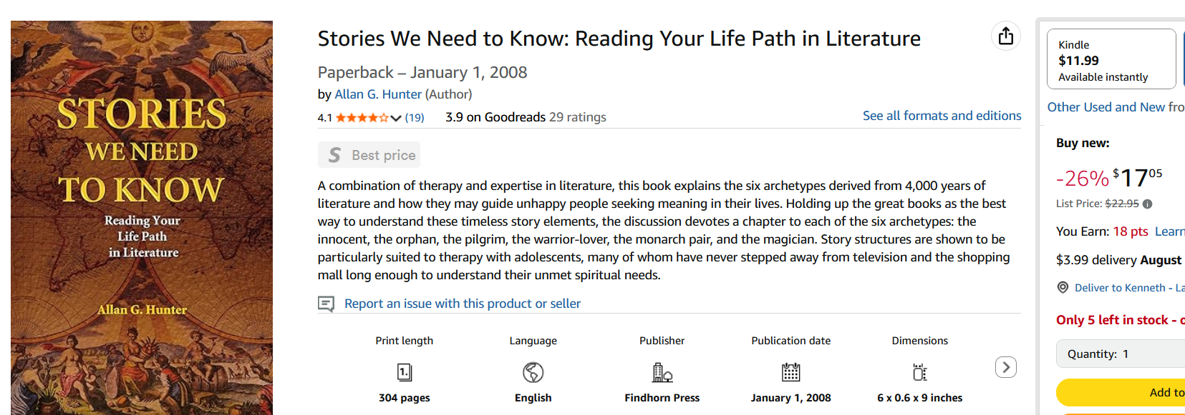
Amazon

